AL NOOR INTERNATIONAL SCHOOL

BRITISH MIDDLE SECTION

GEOGRAPHY GRADE – 5 CHAPTER: 1 - SETTLEMENT

INSTRUCTIONS:

- STUDY THE NOTES FOR THE FIRST LESSON.
- BASED ON THE TEXTBOOK AND NOTEBOOK ANSWER THE ASSIGNMENT AND THE WORKSHEETS.
- Q. 4 c TO BE DONE IN THE NOTE BOOK
- STICK THE NOTES, ASSIGNMENT AND WORKSHEETS IN YOUR GEOGRAPHY NOTEBOOK.
- FOR WORKSHEET 1 REFER TO THE NOTES AND FOR WORKSHEET 2 REFER TO THE TEXT BOOK PAGE NO 31 (COLOUR BOTH THE WORKSHEETS)
- SUBMIT THE WORKSHEETS AND ASSIGNMENT ON 6TH OCTOBER 2009.

NOTES:

1. FACTORS NEEDED TO BUILD A SETTLEMENT:

- The availability of fresh water from a river or a well.
- The need for fertile land for farming
- A nearby source of fuel for cooking and heating as well as wood for building homes.
- The need for land that is easily defended. E.g. On top of a hill.

2. WAYS TO OBTAIN FOOD IN A NEW SETTLE MENT:

The different ways to obtain food in a new settlement are:

- Hunting
- Fishing
- Picking fruits and berries
- Growing crops

3. THE USES OF THE FOLLOWING ARE:

1. RIVER WATER, FISHING
2. SPRING FRESH WATER
3. WOODS HUNTING, FUEL, BUILDING HOUSES
4. SLOPING LAND GRAZING
5. LOWLAND GROWING FRUITS
6. HIGHLAND PROTECTION FROM RAIN, WIND AND ENEMIES

4. THREE MAIN TYPES OF SETTLEMENTS:

- DISPERSED SETTLEMENT: is where the buildings are spread out or scattered.
- LINEAR SETTLEMENT: is where the buildings are arranged in a line usually along a river or a road.
- NUCLEATED SETTLEMENT: these have a compact shape, usually because they have grown up around a central point such as cross roads, T-junction, or maybe a village green or pond.

ASSIGNMENT

Q1 FILL IN THE BLANKS:

- A member of the tribe who has no fixed home and travels from place to place is called:……………………………
- A village is a small group of houses that form ………………………………….. in the country.
- The type of land where animals graze grass or other plants is called ………………………….
- A very large town where many people live and work is called ………………………….
- ………………………………..is an action that is taken for protection against an attack.

Q2 ANSWER THE FOLLOWING:

- Any two factors needed to build a settlement.

  - ……………………………………………………

  - …………………………………………………….
- Any two types of settlement.

  - ……………………………………………………

  - …………………………………………………….
- Any two ways to obtain food in a new settlement.

  - ……………………………………………………

  - …………………………………………………….
- Rivers are important to us. Give 2 reasons. Why?

  - ……………………………………………………

  - …………………………………………………….
- Trees used to be important to the early settlers. Give 2 good reasons. Why?

  - ……………………………………………………

  - …………………………………………………….

Q3 WRITE TRUE OR FALSE AND GIVE THE CORRECT ANSWER FOR FALSE.

- Lowlands are good for grazing animals ( )
- Highlands give protection from wind and enemies ( )
- Springs are sources of unclean water ( )
- Sloping land is used for farming ( )
- Dispersed settlement are those where the buildings are spread out or scattered
( )

WORKSHEET 1
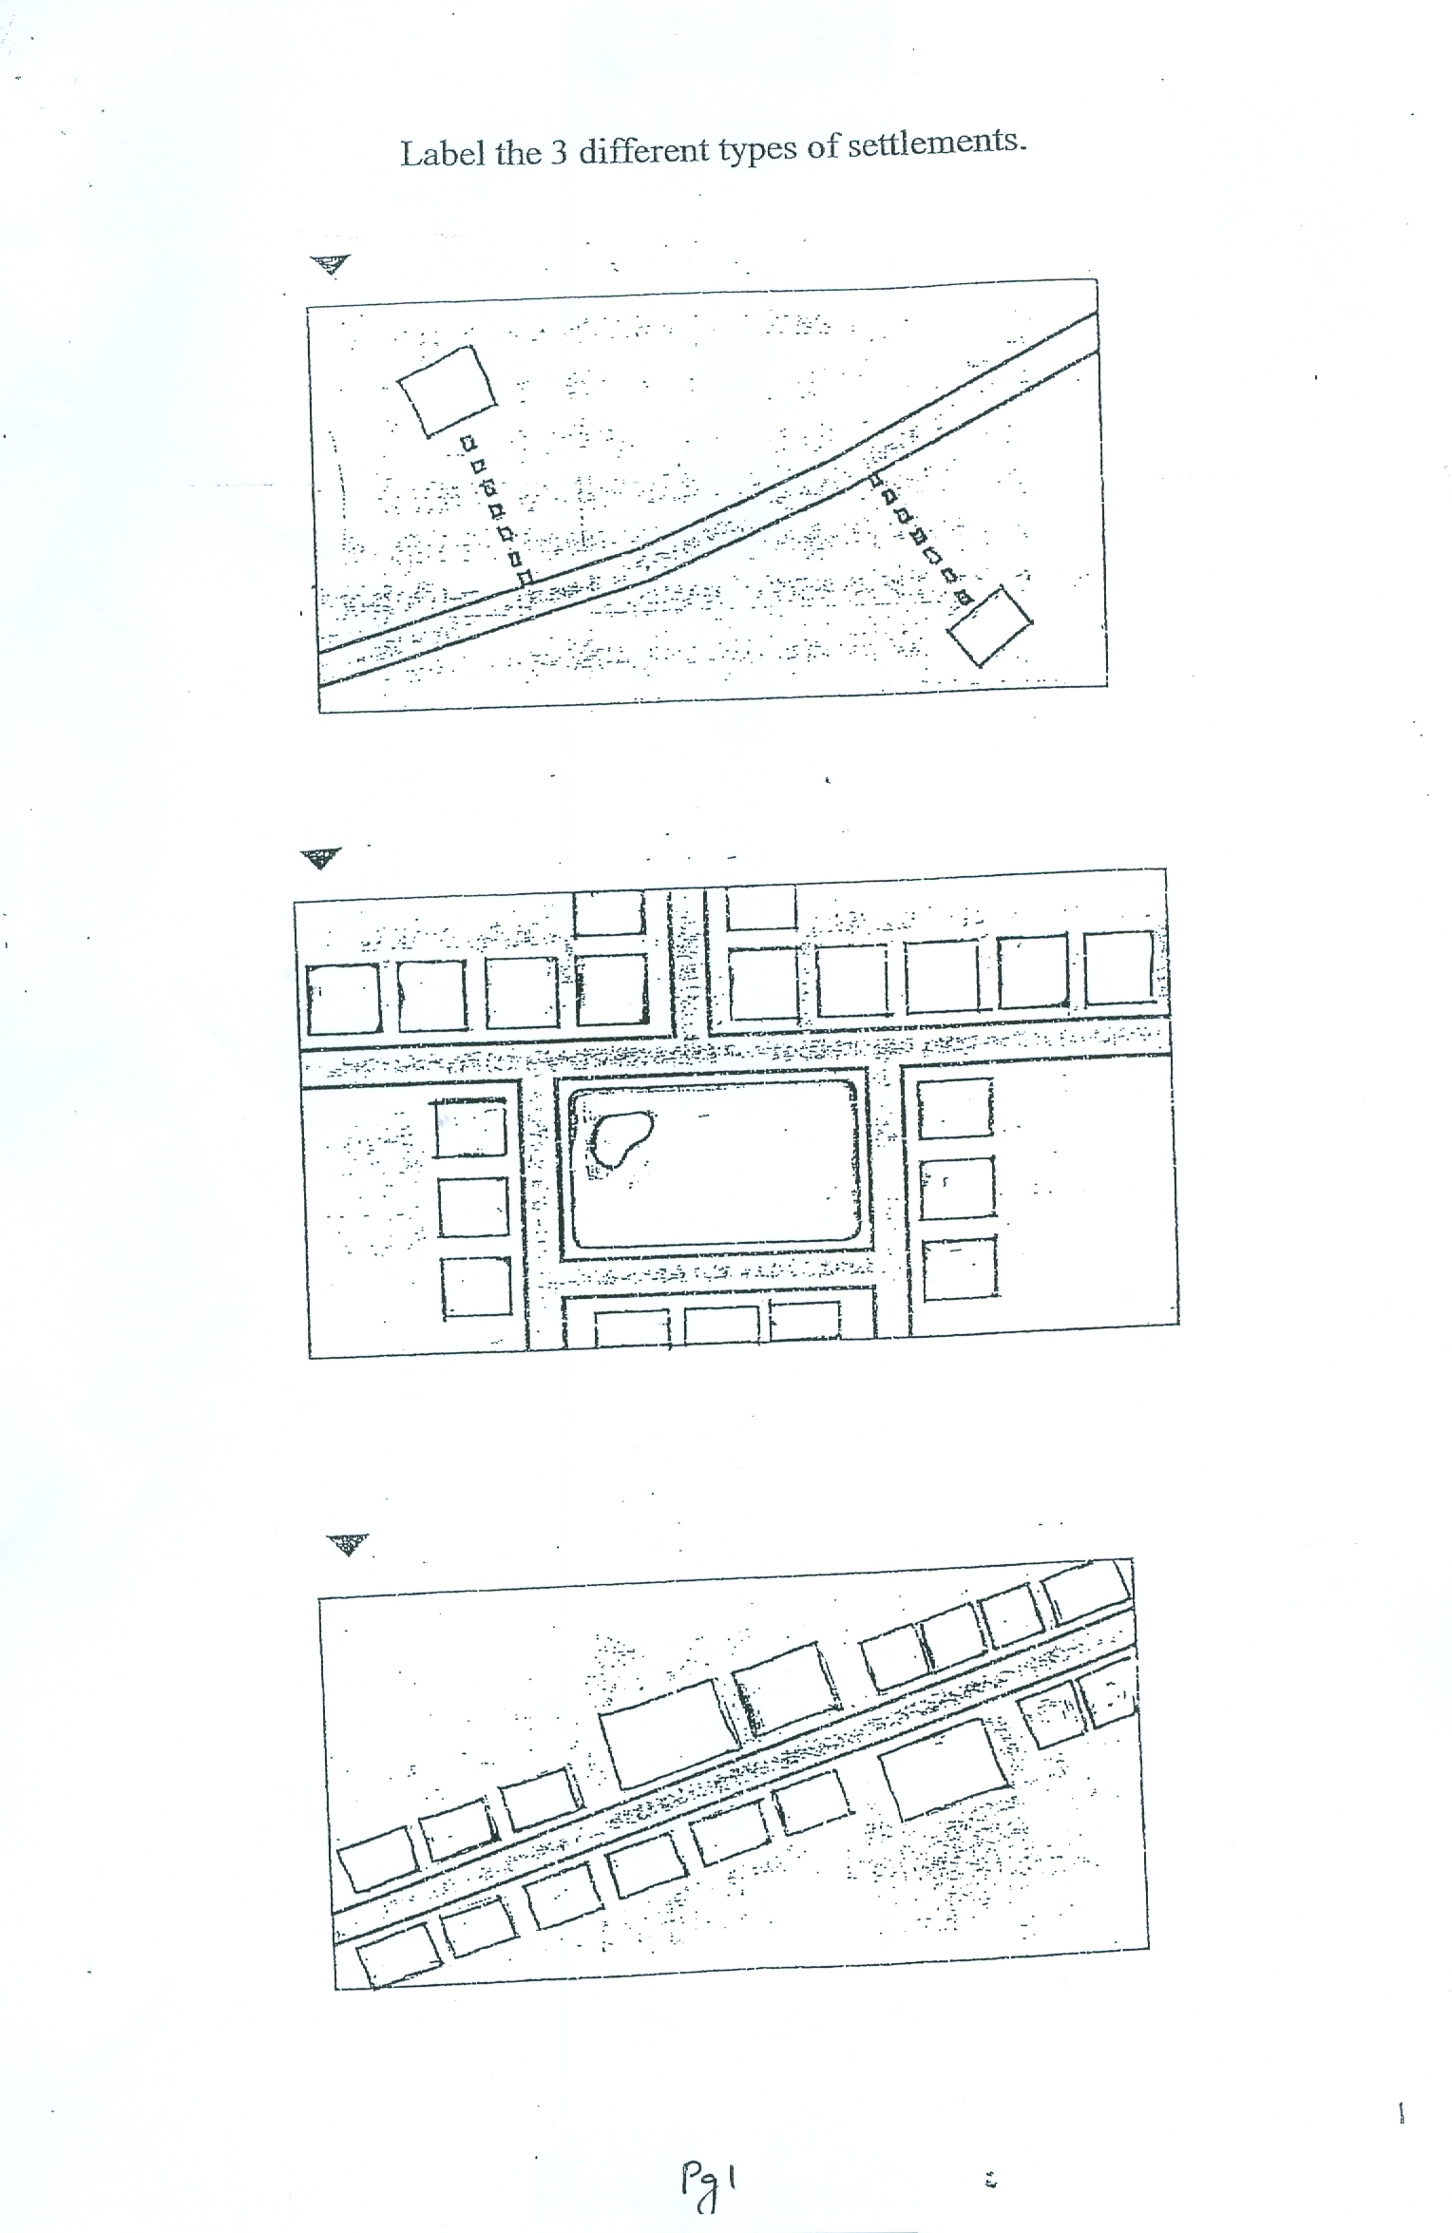

WORKSHEET 2
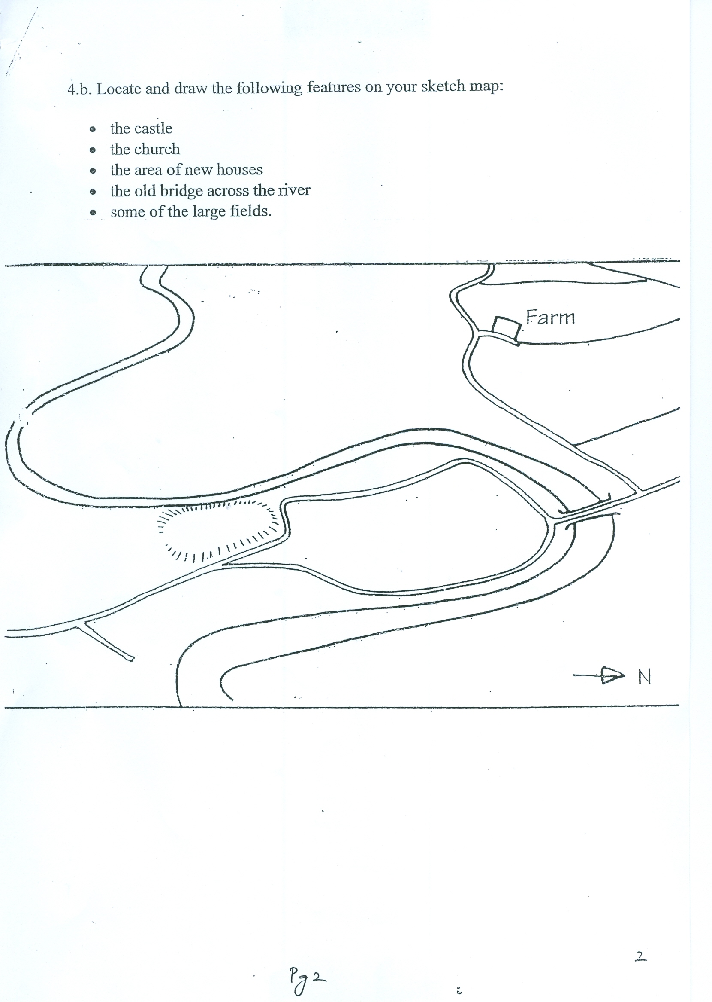
Q 4 c. DRAW A SKETCH MAP OF YOUR OWN. USE THE SKETCH MAP IN 4 b AS A GUIDE. DON’T COPY IT. YOU ALSO NEED TO FILL IN THE FIVE FEATURES FROM 4 b IN YOUR SKECTH MAP. COLOUR IT.

